**Module 3: Trigonometric Identities, Inverse Functions, and Applications**

**II. Inverses of Trigonometric Functions**

After completing this section, you should be able to:

* graph and identify properties of the inverse trigonometric functions
* simplify and evaluate expressions involving inverse trigonometric functions

**A. The Inverse Sine, Cosine, and Tangent Functions**

A function that is one-to-one has an inverse. According to the horizontal-line test, a function is one-to-one if no horizontal line crosses the graph of the function more than once. (If you are not well acquainted with the concepts of one-to-one function, inverse function, and the horizontal-line test, it is worth reviewing module 1, topic III-C.)

**The Inverse Sine Function**

Consider the graph of the sine function. The domain of the sine function consists of all real numbers. A horizontal line may cross the sine graph infinitely many times. Therefore, there is no inverse function of the sine function with domain (-∞, ∞).

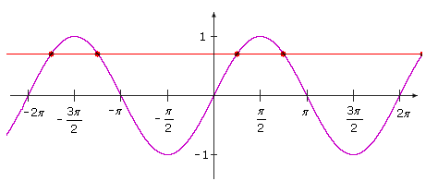

However, if the domain of the sine function is restricted to a particular interval, then the corresponding graph does pass the horizontal line test.

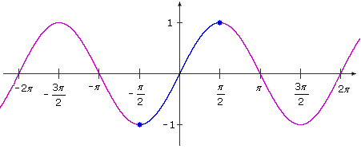

By convention, mathematicians restrict the domain of the sine function to the interval [-π/2, π/2]. Since the sine function is increasing for this entire interval, the sine function passes the horizontal-line test. Therefore, there is an inverse function corresponding to the sine function with restricted domain [-π/2, π/2].

The inverse sine function is denoted by sin–1 or arcsin.

*y* = sin–1*x* means "*y* is the inverse sine of *x*," or "*y* is the angle whose sine equals *x*." Since the domain of the sine function is restricted to [-π/2, π/2] and has range [-1, 1], the inverse sine function has domain [-1, 1] and range [-π/2, π/2]. The graph of the inverse sine function is the graph of the restricted sine function reflected across the line *y* = *x*.

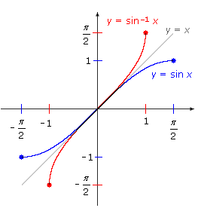

Points of interest on the sine graph include (–π/2, –1) and (π/2, 1). Points of interest on the inverse sine graph include (–1, –π/2) and (1, π/2). The sine graph and the graph of its inverse are shown separately below, with the same points of interest highlighted. Some additional points on the graphs are compiled in the tables below.

|  |  |  |
| --- | --- | --- |
|  |  |  |

|  |  |  |  |  |  |  |  |  |  |  |  |  |  |  |  |  |  |  |  |  |  |  |  |  |  |  |  |  |  |  |  |  |  |  |  |  |  |  |  |  |  |  |  |  |  |  |  |  |  |
| --- | --- | --- | --- | --- | --- | --- | --- | --- | --- | --- | --- | --- | --- | --- | --- | --- | --- | --- | --- | --- | --- | --- | --- | --- | --- | --- | --- | --- | --- | --- | --- | --- | --- | --- | --- | --- | --- | --- | --- | --- | --- | --- | --- | --- | --- | --- | --- | --- | --- |
| |  |  |  |  |  | | --- | --- | --- | --- | --- | | **Restricted Sine Function** | |  | **Inverse Sine Function** | | | Domain [–π/2, π/2] | Range [–1, 1] | Domain [–1, 1] | Range [–π/2, π/2] | | *x* | *y* = sin *x* | *x* | *y* = sin–1 *x* | | –π/2 | –1.0 | –1.0 | –π/2 | | –π/3 | /2 ≈ –0.8660 | /2 | –π/3 | | –π/4 | /2 ≈ –0.7071 | /2 | –π/4 | | –π/6 | –0.5 | –0.5 | –π/6 | | 0 | 0.0 | 0.0 | 0 | | π/6 | 0.5 | 0.5 | π/6 | | π/4 | /2 ≈ 0.7071 | /2 | π/4 | | π/3 | /2 ≈ 0.8660 | /2 | π/3 | | π/2 | 1.0 | 1.0 | π/2 | |

**Caution:** Do not confuse the inverse sine function sin–1 *x*with the cosecant function 1/(sin *x*). They are not the same. For example, sin–1 0.5 = π/6 ≈ 0.5236, but 1/(sin 0.5) ≈ 2.0859.

**The Inverse Cosine Function**

Consider the graph of the cosine function.

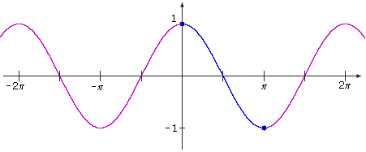

By convention, mathematicians restrict the domain of the cosine function to the interval [0, π]. Since the cosine function is decreasing for this entire interval, the cosine function passes the horizontal-line test. Therefore, there is an inverse function corresponding to the cosine function with restricted domain [0, π].

The inverse cosine function is denoted by cos–1 or arccos. Since the domain of the cosine function is restricted to [0, π] and has range [-1, 1], the inverse cosine function has domain [-1, 1] and range [0, π]. The graph of the inverse cosine function is the graph of the (restricted) cosine function reflected across the line *y* = *x*.

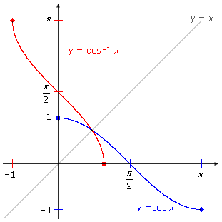

Points of interest on the cosine graph include (0, 1) and (π, –1). Points of interest on the inverse cosine graph include (–1, π) and (1, 0). The cosine graph and the graph of its inverse are shown separately below, with the same points of interest highlighted. Some additional points on the graphs are compiled in the tables below.

|  |  |
| --- | --- |
|  |  |

|  |  |  |  |  |
| --- | --- | --- | --- | --- |
| **Restricted Cosine Function** | |  | **Inverse Cosine Function** | |
| Domain [0, π] | Range [–1, 1] | Domain [–1, 1] | Range [0, π] |
| *x* | *y* *=* *cos x* | *x* | *y* *=* *cos*–1*x* |
| 0 | 1.0 | 1.0 | 0 |
| π/6 | /2 ≈ 0.8660 | /2 | π/6 |
| π/4 | /2 ≈  0.7071 | /2 | π/4 |
| π/3 | 0.5 | 0.5 | π/3 |
| π/2 | 0.0 | 0.0 | π/2 |
| 2π/3 | –0.5 | –0.5 | 2π/3 |
| 3π/4 | –/2 ≈ –0.7071 | –/2 | 3π/4 |
| 5π/6 | –/2 ≈ –0.8660 | –/2 | 5π/6 |
| π | –1.0 | –1.0 | π |

**Caution:** Do not confuse the inverse cosine function cos–1 *x*with the secant function 1/cos *x*. They are not the same. For example, cos-1 1 = 0, but 1/(cos 1) ≈ 1.8508.

**Example II.A.1:** Determine .

Solution:

Start with the expression inside the brackets, .

 means that , and *θ* is in the interval [0, π].

Since  and , we know that *θ* is between π/2 and π, and so *θ* = *5*π/6.

Then .

**The Inverse Tangent Function**

Consider the graph of the tangent function.

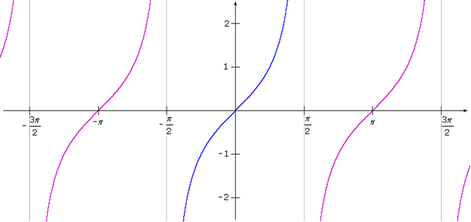

By convention, mathematicians restrict the domain of the tangent function to the interval (-π/2, π/2). Since the tangent function is increasing on this interval, it passes the horizontal-line test. Therefore, there is an inverse function corresponding to the tangent function with restricted domain (-π/2, π/2).

The inverse tangent function is denoted by tan–1 or arctan. Since the domain of the tangent function is restricted to (-π/2, π/2) and the tangent function has range (-∞,∞), the inverse tangent function has domain (-∞,∞) and range (-π/2, π/2). The graph of the inverse tangent function is the graph of the (restricted) tangent function reflected across the line *y* = *x*.

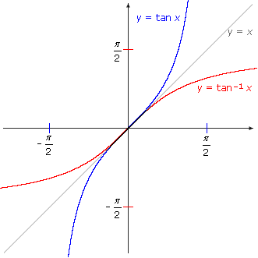

The graph of the tangent has vertical asymptotes *x* = –π/2 and *x* = π/2. The graph of the inverse tangent has horizontal asymptotes *y* = –π/2 and *y* = π/2. The tangent graph and the graph of its inverse are shown separately below. Some points on the graphs are compiled in the tables below.

|  |  |
| --- | --- |
|  |  |

|  |  |  |  |  |
| --- | --- | --- | --- | --- |
| **Restricted Tangent Function** | |  | **Inverse Tangent Function** | |
| Domain (–π/2, π/2) | Range (-∞, ∞) | Domain (-∞, ∞) | Range (–π/2, π/2) |
| *x* | *y* *=* *tan x* | *x* | *y* *=* *tan*–1*x* |
| –π/2 | undefined | undefined | –π/2 |
| –π/3 | – ≈ –1.7321 | – | –π/3 |
| –π/4 | –1 | –1 | –π/4 |
| –π/6 | –/3 ≈ –0.5774 | –/3 | –π/6 |
| 0 | 0 | 0 | 0 |
| π/6 | /3 ≈ 0.5774 | /3 | π/6 |
| π/4 | 1 | 1 | π/4 |
| π/3 | ≈ 1.7321 |  | π/3 |
| π/2 | undefined | undefined | π/2 |

**Caution:** Do not confuse the inverse tangent function tan–1 *x*with the cotangent function 1/tan *x*. They are not the same. For example, tan–1 1 = π/4 ≈ 0.7854, but 1/(tan 1) ≈ 0.6421.

**Example II.A.2:** Determine tan–1 7.5.

**Solution:**

*θ* = tan–1 7.5 means that tan *θ* = 7.5 and *θ* is in the interval (–π/2, π/2).

*θ* is not one of the "standard" angles, so using a calculator (in RADIAN mode), you will find that *θ* is approximately 1.4382.

Thus, tan–1 7.5 ≈ 1.4382 radians.

**B. Expressions Involving Inverse Trigonometric Functions**

Recall that for a function *f* and its inverse, *f*–1, the composition *f ◦ f*–1 satisfies the equation (*f* *◦ f* –1)(*x*) = *f*(*f*–1 (*x*)) = *x* for all *x* in the domain of the inverse function *f*–1.

In the case of the trigonometric functions and their inverses:

sin (sin–1 *x*) = *x* for all *x* in the interval [–1, 1], the domain of the inverse sine function.

cos (cos–1 *x*) = *x* for all *x* in the interval [–1, 1], the domain of the inverse cosine function.

tan (tan–1 *x*) = *x* for all *x* in the interval (-∞,∞), the domain of the inverse tangent function.

**Example II.B.1:** Find the exact values of  and .

**Solution:**

Applying the composition identities above, and .

Even if you do not remember the composition identities, the results are easy to determine by substituting the values for  and tan–1 (–1), as follows:

, and .

Also, for a function *f* and its inverse, *f*–1, the composition *f*–1 ◦ *f* satisfies the equation (*f*–1 ◦ *f*)(*x*) = *f*–1 (*f*(*x*)) = *x* for all *x* in the domain of *f* (which is equal to the range of *f*–1).

In the case of the trigonometric functions and their inverses:

sin–1 (sin *x*) = *x* for all *x* in the interval , the range of the inverse sine function.

cos–1 (cos *x*) = *x* for all *x* in the interval [0,π], the range of the inverse cosine function.

tan–1 (tan *x*) = *x* for all *x* in the interval , the range of the inverse tangent function.

**Example II.B.2:** Find the exact value of .

Solution:

|  |  |  |
| --- | --- | --- |
|  |  | Apply the identity sin–1 (sin *x*) = *x* for *x* =  in the interval . |
| **Alternative method:** | | |
|  |  | Evaluate . |
|  |  | and is in the interval. |

**Example II.B.3:** Find the exact value of .

**Solution:**

|  |  |  |
| --- | --- | --- |
| is not equal to , because  is not in , the range of the inverse sine function. The identity sin–1 (sin *x*) = *x* does not apply. Another approach is necessary to find the appropriate angle in the interval . | | |
|  |  | Evaluate . |
|  |  | and is in the interval . |
| Therefore, |  |  |

**Example II.B.4:** Find the exact value of .

**Solution:**

|  |
| --- |
|  |

|  |  |
| --- | --- |
|  | Apply the sum identity for the sine. |
| Since  is positive,  is the angle *θ* (in quadrant I) whose tangent is equal to . That is,  for angle *θ* between 0 and . This angle *θ* is not a "standard" angle. | |
| Draw a reference triangle for *θ*, with opposite side of length 1 and adjacent side of length 2, so that .  The hypotenuse has length   Referring to the triangle, , so |  |
| , and | |
| Apply a similar approach for :  Since  is positive,  is the angle *φ*  (in quadrant I) whose cosine is equal to . | |
| Draw a reference triangle for *φ*, with adjacent side of length 3 and hypotenuse of length 5, so that .  The other leg has length . |  |
| Referring to the triangle, ,, and .  Now substitute the values into the expression involving sines and cosines to get          Therefore, . | |

[*Return to top of page*](https://umuc.equella.ecollege.com/file/51ed41e5-be80-4110-8171-a40ed58c98af/1/Inverses%20of%20Trigonometric%20Functions.html#pagetop)

[**Report broken links or any other problems on this page.**](http://help.umuc.edu/)  
  
[**Copyright © by University of Maryland University College.**](https://umuc.equella.ecollege.com/file/51ed41e5-be80-4110-8171-a40ed58c98af/1/MATH108-0609.zip/common/copyright.html)